Project: Lipid Mediator Profile Response to Triphenyl Phosphate Exposure

Sample Processing: Michael La Frano
Lipid Mediator Analysis: Michael La Frano
Data QA: Michael La Frano and John Newman
Report Generation: Michael La Frano (07/14/2015)

Collaborator: Michele La Merrill, PhD
Department of Environmental Toxicology
University of California, Davis
1 Shields Ave., Davis, CA 95616

Summary – This study aims to identify changes in lipid mediators in the hypothalamus with triphenyl phosphate (TPP) exposure. UC Davis type 2 diabetes mellitus (UCD-T2DM) rats were treated with TPP (n=8 per group) or not treated (n=8 per group). Each group was analyzed for oxylipin, nitro lipids, endocannabinoid, and endocannabinoid-like monoacylglycerol and N-acylethanolamide changes to investigate alterations in lipid mediator signaling due to TPP exposure. Targeted metabolomic analysis of lipid mediators in rat hypothalamus samples was performed by the Newman lab.
Analytical results generally met quality control criterion with respect to surrogate recoveries and replicate precision. Surrogate recoveries were good for most oxylipins (45-89%) and endocannabinoids (35-60%). Recovery precision was good for most analytes in these profiles, ranging from 12-23% RSD for the oxylipin surrogates. As is often observed with this extraction method, the d17-10-nitroleate surrogate had lower recoveries (25% and high variance (39%). Analytical precision was assessed by duplicate analysis of two hypothalamus samples from a separate study. Analytical precision was good for oxylipins in the two replicates, with 76 and 67% of analytes with <30% RSD, respectively. Oxylipins showing particularly high replicate variance (40-55%) were 10-Nitroleate, 17-HDoHE, and 4-HDoHE. Regarding endocannabinoids, while one replicate showed excellent reproducibility (93% of analytes with <30% RSD), the other replicate had just 27% of analytes with <30% RSD. Endocannabinoids in the latter replicate showing particularly high replicate variance (50-80%) were monoacylglycerols (1-AG, 2-AG, 2-LG, and 2-OG). Coefficient of determination was performed for each replicate. The R² for the analytes within these samples was excellent for all replicates, ranging from 0.94-0.99. In addition, calculating lipid mediator concentrations as relative abundance decreased replicate precision variance, indicating that the endocannabinoid replicate with high variance was likely due to tissue heterogeneity.
A general overview of the data can be seen on pages 2-3. Lipid mediator concentrations for each of the groups can be seen in Figure 1. A cursory statistical analysis of non-normalized raw data was also performed in the associated Excel file deliverable. Cross correlation plots reveal correlations between select analytes, some group specific (See Figure 2 below).
The final page contains a manuscript-ready description of the methods. The complete data set and an analyte list is in the associated excel file (La Merrill–Deliverable-Newman.xls).

Figure 1. Lipid mediator concentrations in groups
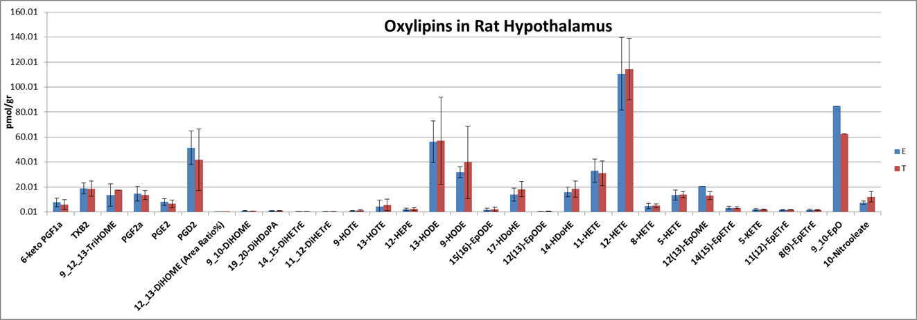
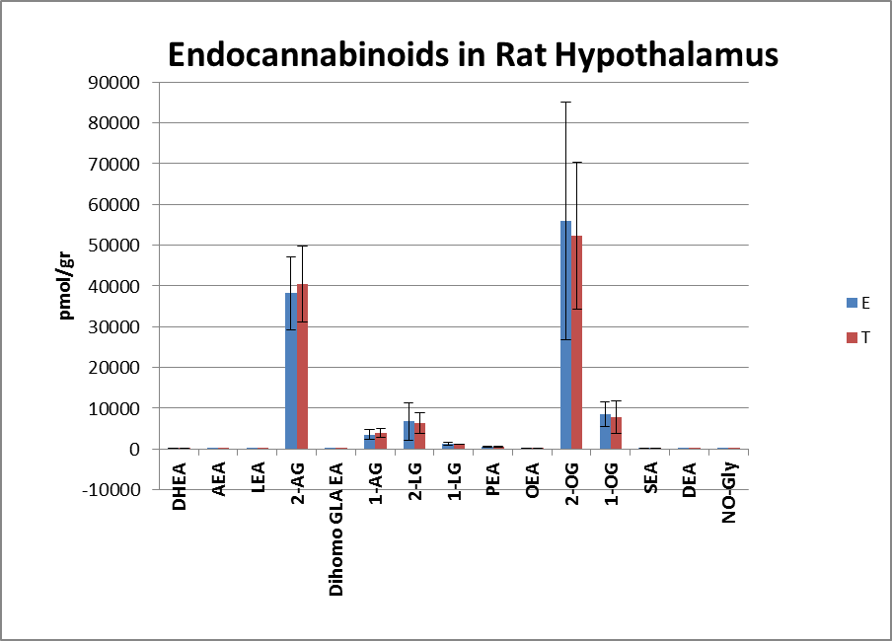

Figure 2. Cross correlation plots of lipid mediators

- All Data for both groups (B) “E” treatment group (C) “T” treatment group
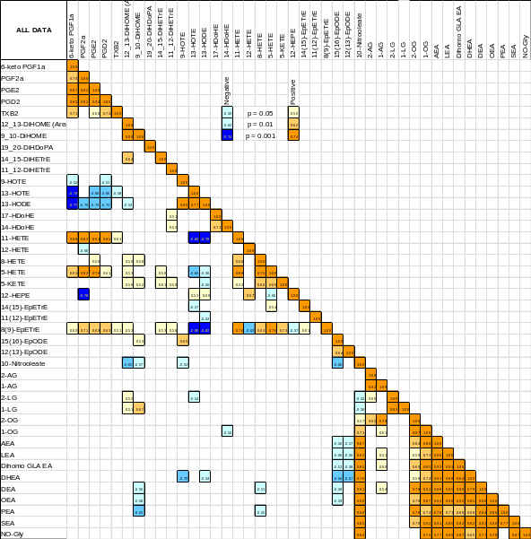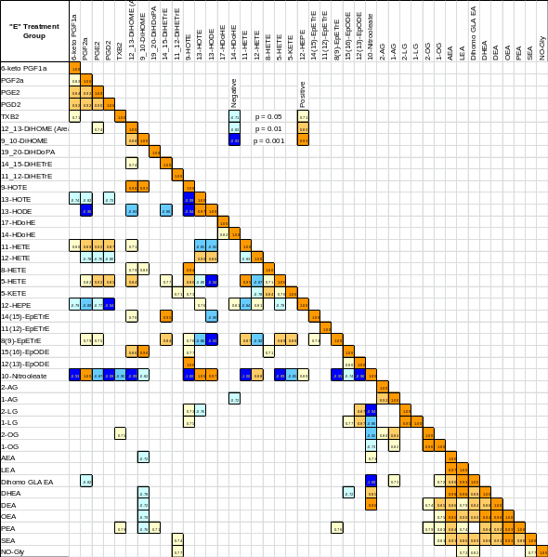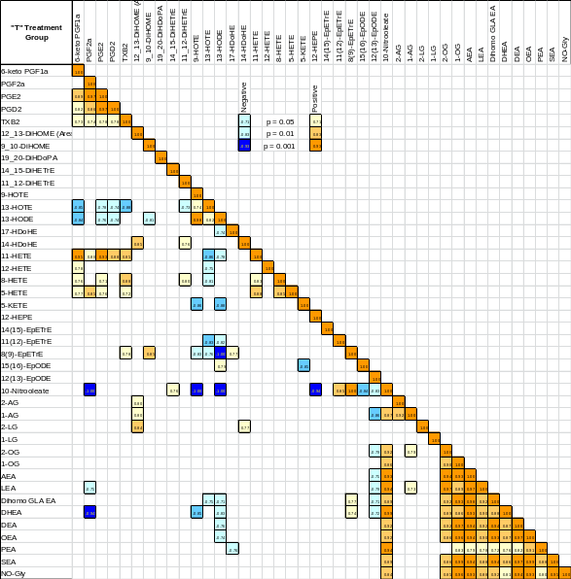

Methods:

Sample extraction – Oxylipins and endocannabinoids were isolated using a Waters Ostro Sample Preparation Plate (Milford, MA). Hypothalamus samples were pulverized and aliquoted (~20-25mg) were added to 2mL polypropylene tubes and spiked with a 5 µL anti-oxidant solution (0.2 mg/ml solution BHT/EDTA in 1:1 MeOH:water) and 10 μL 1000nM analytical deuterated surrogates. A total of 100 µL methanol was added to the sample and vrtexed 90 sec. Next, 500 µL D.I. water and 1000 µL ethyl acetate was added and the tube was vortexed 3 minutes, before being centrifuged at 15,000g for 10 min at room temp. The supernate was then transferred into a clean 2 mL autosampler vial. The extraction with ethyl acetate was repeated and the eluent was dried by speed vacuum for 35 min at the medium BP setting. Once dry, samples were re-constituted with the internal standard 1-cyclohexyl ureido, 3-dodecanoic acid (CUDA) and 1-Phenyl 3-Hexadecanoic Acid Urea (PHAU) at 100 nM (50:50 MeOH:CAN), vortexed 1 min, transferred to a spin filter (0.1 µm, Millipore, Billerica, MA), centrifuged for 3 min at 6ºC at <4500g (rcf), before being transferred to 2 mL LC-MS amber vials. Extracts were stored at -20ºC until analysis by UPLC-MS/MS. The internal standard was used to quantify the recovery of surrogate standards.

Lipid mediator analysis - Analytes in a 100 μL extract aliquot were separated utilizing a Waters Acquity UPLC (Waters, Milford, MA) with a solvent gradient using modifications of a previously published protocols for oxylipins (1) and endocannabinoids (2). Samples were held at 10ºC. Separated residues were detected by negative mode electrospray ionization for oxylipins and positive mode electrospray ionization for endocannabinoids using multiple reaction monitoring on an API 4000 QTrap (AB Sciex, Framingham, MA, USA). Analytes were quantified using internal standard methods and 5 to 10 point calibration curves (r2 ≥ 0.997). Calibrants and internal standards were either synthesized [10,11-DHN, 10,11-DHHep, 10(11)-EpHep and CUDA] or purchased from Cayman Chemical (Ann Arbor, MI), Avanti Polar Lipids Inc. (Alabaster, AL), unless otherwise indicated. Larodan Fine Lipids (Malmo, Sweden) provided the linoleate derived triols 9,12,13-TriHOME and 9,10,13- TriHOME. Data was processed utilizing AB Sciex MultiQuant version 3.0.2.

References -
(1) Strassburg K et al (2012). Quantiitative profiling of oxylipins through comprehensive LC-MS/MS analysis: application in cardiac surgery. Anal Bioanal Chem. 404:1413-26.
(2) Grapov D et al (2012). Type 2 Diabetes Associated Changes in the Plasma Non-Esterified Fatty Acids, Oxylipins and Endocannabinoids. PLoS ONE. 7(11):e48852.

