
mView™ REPORT
Serum Metabolites at Defined Stages of Liver Disease

UNTX-03-20VW

CLIENT: University of Texas Health Science Center
Kristin Eckel-Mahan, PhD
AUTHOR: Greg Palczewski, PhD
APPROVAL: Priya Ramamoorthy, PhD
DATE: April 17, 2021



Metabolon, Inc. • 617 Davis Drive, Suite 100, Morrisville, NC 27560 • (919) 572-1711 www.metabolon.com • Contact: info@metabolon.com

Table of Contents
Objective 3
Experimental Procedures 3
Results and Biological Interpretation 4
Metabolite Summary and Significantly Altered Biochemicals 4
Biological Interpretation 6
Data Overview 7
Principal Component Analysis (PCA) 7
Observed Biochemical Differences 8
Central Carbon Metabolism 8
Lipid Metabolism 9
Phospholipids Metabolism 11
Branched Chain Amino Acids 12
Conclusions 14
Study Parameters 15
Data Quality: Instrument and Process Variability 15
Appendix 16
Metabolon Platform 16
Statistical Methods and Terminology 20

Objective

Purpose of Experiment
The goal of this study was to reveal serum metabolome differences at defined stages of liver disease from fatty liver to hepatocellular carcinoma.

Experimental Procedures

Experimental design
Metabolon received 40 mouse serum samples on January 26, 2021. Global metabolic profiles were determined from the experimental groups outlined in the table below.

Group | Group ID | Description | n
1 | Con_4wk | Control - 4 weeks of age (time when mice were switched to HFD) | 5
2 | STZ_4wk | Streptozotocin mice 4 weeks of age (time when mice were switched to HFD) over to HFD) | 5
3 | Con_7wk | Control + HFD - 7 weeks of age (NASH evident) | 5
4 | STZ_7wk | Streptozotocin + HFD - 7 weeks of age (NASH evident) | 5
5 | Con_10wk | Control + HFD - 10 weeks of age (fibrosis evident) | 5
6 | STZ_10wk | Streptozotocin + HFD - 10 weeks of age (fibrosis evident) | 5
7 | Con_16wk | Control + HFD- 16 weeks of age (HCC evident) | 5
8 | STZ_16wk | Streptozotocin + HFD- 16 weeks of age (HCC evident) | 5

Results and Biological Interpretation

Metabolite Summary and Significantly Altered Biochemicals
The present dataset comprises a total of 978 compounds of known identity (named biochemicals). Following log transformation and imputation of missing values, if any, with the minimum observed value for each compound, ANOVA contrasts were used to identify biochemicals that differed significantly between experimental groups. A summary of the numbers of biochemicals that achieved statistical significance (p≤0.05), as well as those approaching significance (0.05<p<0.10), is shown below. Analysis by two-way ANOVA identified biochemicals exhibiting significant interaction and main effects for experimental parameters of time and treatment.
An estimate of the false discovery rate (q-value) is calculated to take into account the multiple comparisons that normally occur in metabolomic-based studies. For example, when analyzing 200 compounds, we would expect to see about 10 compounds meeting the p≤0.05 cut-off by random chance. The q-value describes the false discovery rate; a low q-value (q<0.10) is an indication of high confidence in a result. While a higher q-value indicates diminished confidence, it does not necessarily rule out the significance of a result. Other lines of evidence may be taken into consideration when determining whether a result merits further scrutiny. Such evidence may include a) significance in another dimension of the study, b) inclusion in a common pathway with a highly significant compound, or c) residing in a similar functional biochemical family with other significant compounds. Refer to the Appendix for general definitions and further descriptions of false discovery rate and other statistical tests used at Metabolon.

We have also included in the electronic deliverables, a file with data for each biochemical displayed as box plots like that shown in the example figure below.

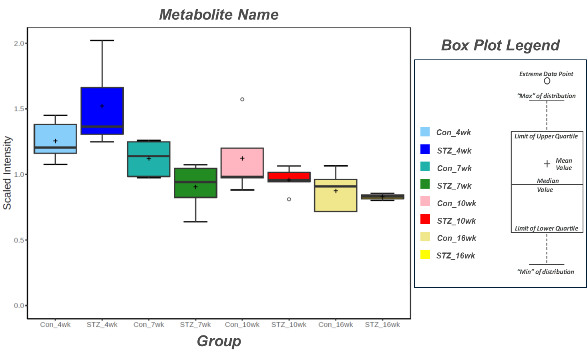

Biological Interpretation
The digestive system is comprised of a series of organs with clear physical separation. In addition to physical separation, each of these organs carries out a specific function that is largely unique to that organ. Despite this clear division of function, organs of the digestive system are in constant interaction with each other using chemical messengers (e.g., insulin) or under the control of the nervous system (PMID: 22392290). As such, diseases that can be associated with changes in a single organ can have a profound impact on other organs. The high prevalence of obesity in modern times as such has resulted in growing population of individuals with impaired insulin response (insulin insensitivity and/or hypoinsulinemia). While the cause of insulin dysregulation can be caused by changes within the pancreas, the impact of these changes can be observed in other organs, such as a greater risk of fatty liver disease.

To identify the metabolic changes associated with beta-cell mediated liver disease the investigator submitted serum samples from mice treated with streptozotocin (STZ, toxic to beta cells). Additional details are provided in the above Experimental Procedures section. The samples were loaded in an equivalent manner (by volume) across the analytical platforms and no further normalization was required. The provided Excel data tables (Data Table) includes the raw (and normalized) values for each sample, while the statistical analysis results (Heatmap) can be found in the corresponding Excel data file.

Datasets provided in the mView product can be quite large and contain a great deal of information. A few observations are offered below as an initial overview of metabolomic changes observed in the various groups. This report first presents statistical analysis of the experimental samples by various methods, including principal component analysis, followed by a discussion of the metabolic pathways and biochemicals that differed between the various groups.

Data Overview

Principal Component Analysis (PCA)
Principal component analysis (PCA) is a statistical method that can be used to obtain a high-level view of large datasets. It uses an orthogonal transformation to convert a set of observations of possibly correlated variables into a set of variables called principal components. The method permits visualization of how individual samples in a dataset differ from each other. Samples with similar biochemical profiles cluster together whereas samples with distinct profiles segregate from one another. PCA can also be used to quickly assess the magnitude of effect of experimental conditions compared to each other as well as to population variability.
A PCA of the serum samples resulted in several distinct groupings (Figure 1). Notably, all samples collected at 4 weeks, separate along Principal Component 1 (PC1), and further by treatment. This suggests that even at 4 weeks, that the STZ and Con groups already have marked differences in their metabolic profile. Further separation between the Con and STZ at later time points is also apparent. This separation is likely the result of dietary change at 4 weeks. Treatment with STZ appears to impact how these mice respond to this dietary change. As these two groups do not separate along PC1 this may suggest that there are also numerous conserved differences (as compared to 4-week) in these two groups.

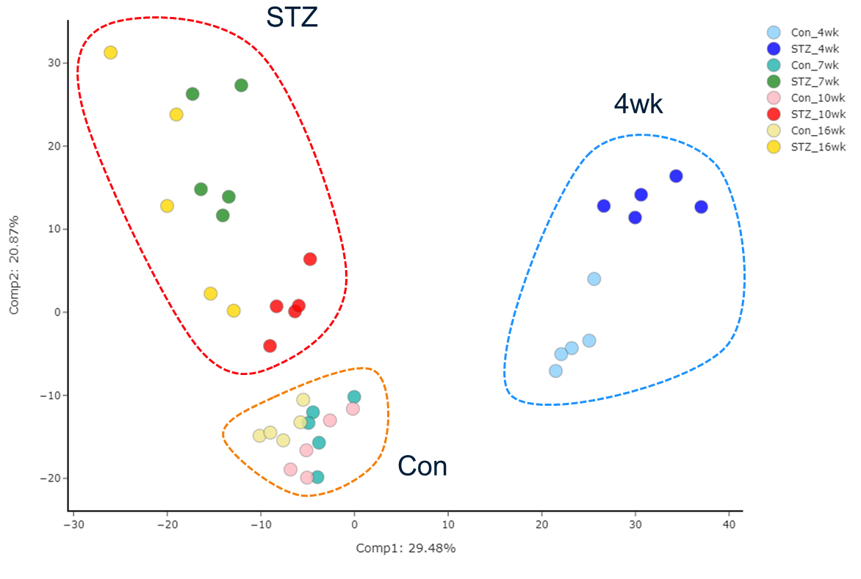
Figure 1. Principal Component Analysis (PCA) of all samples, color coded by experimental group.

Observed Biochemical Differences

Central Carbon Metabolism
The liver is central to regulating circulating levels of substrates used for cellular energy generation. This includes several aspects, such as bidirectional nutrient shuttles (Cori and Cahill Cycle), energy release (glucose, lipids, ketone bodies), and de novo lipid synthesis for energy sequestration. During NAFLD progression these pathways can become perturbed resulting in the accumulation of lipids within the liver, a consequence of excess lipid synthesis and insufficient release into the circulation.

One of the most striking differences observed within this data set is the expected accumulation of glucose within the STZ treated group (Figure 2). Interestingly, at and after 7 weeks, STZ mice have lower levels of circulating glutamate and glutamine, due to declining levels over time of these metabolites within STZ mice (control mice have relatively consistent levels). If peripheral tissues are unable to adequately take up glucose within STZ mice, due to the absence of insulin, they may begin relying on other carbon sources, though glutamine transport is insulin sensitive (PMID: 8064410) and one may expect a concordant increase in alanine to shuttle excess nitrogen back to the liver. Lactate levels though remain fairly consistent across all groups and time. As lactate is produced by the periphery and recycled by the liver, it may suggest that liver is still able to function (to some degree), even when fibrosis and carcinoma are evident.

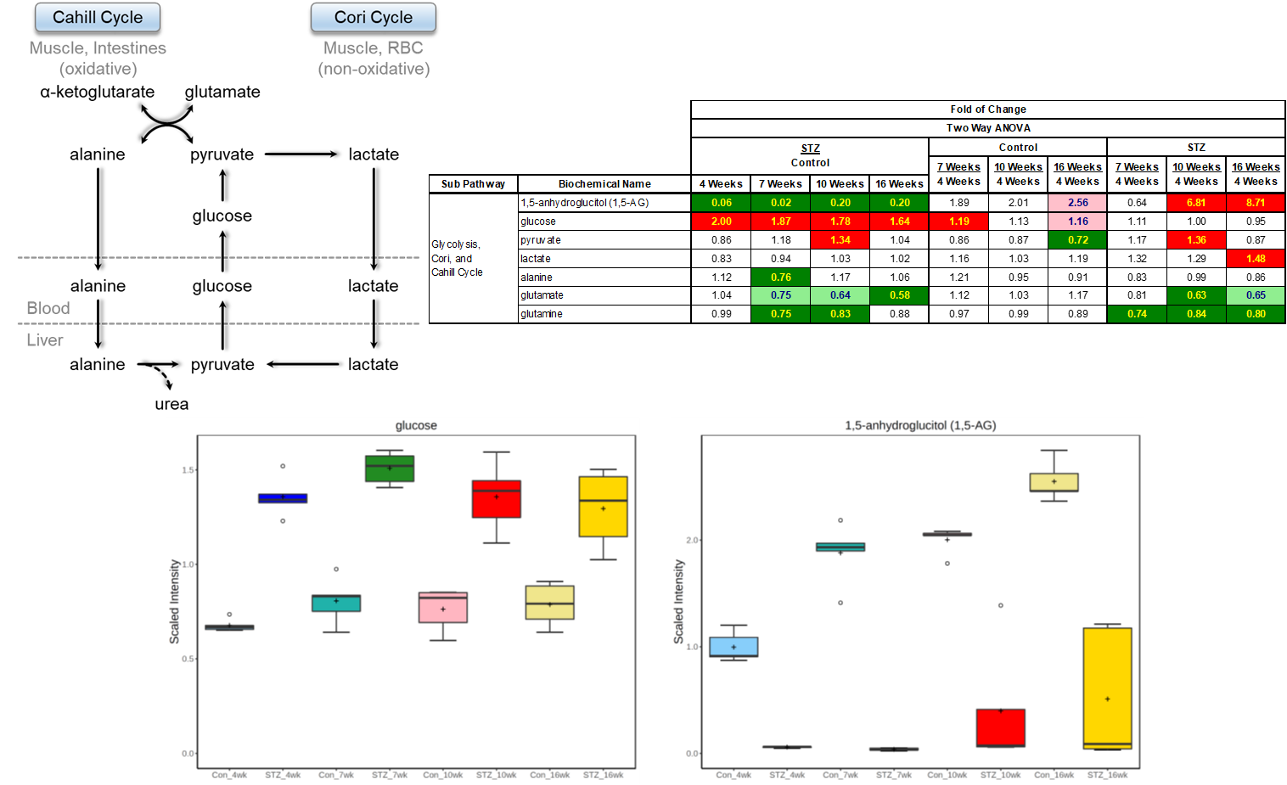
Figure 2. Statistical heat map, pathway diagram, and boxplot of metabolites associated peripheral and liver glycolytic pathways. Trending (0.05 < p < 0.10) and significant (p ≤ 0.05) elevations are indicated by pink and red, respectively, while trending and significant reductions are represented by light green and dark green, respectively.

Lipid Metabolism
The liver is a primary site of de novo lipogenesis and release of lipids via lipoproteins. The turnover of lipids stores is governed by dietary composition as well energetic demands of the peripheral tissues. During NAFLD progression, lipid droplets rich in triacylglycerides (TAG) are formed and contribute to hepatocyte stress.

Generated by lipases during TAG metabolism, levels of monoacyl- and diacyl-glycerides can serve as markers of changes in lipid metabolism. Here we observe a dramatic effect of STZ treatment and HFD on circulating levels of lipid stores (Figure 3). Interestingly, despite apparent differences in glucose level at 4 weeks between the STZ and Con group, levels of MAGs and DAGs are fairly similar between these groups at this time point. This is particularly interesting, as even though a control diet is not enriched in fats, there is still a considerable amount of fat (5-10% by weight) and lipase activity is insulin sensitive (PMID: 3552532). This may suggest that despite STZ treatment, mice are able to regulate circulating lipid stores, a function carried out by the liver and periphery, fairly well unless they are additionally challenged by a high fat diet. In such a case, levels of DAGs and MAGs are robustly elevated within the STZ group (vs. Con), and this difference is largely due to the changes happening within the STZ group (Con remains relatively not impacted by diet). These differences may either suggest a difference in periphery lipase activity, nutrient uptake by the periphery, or lipid store release (via lipoproteins) by the liver.
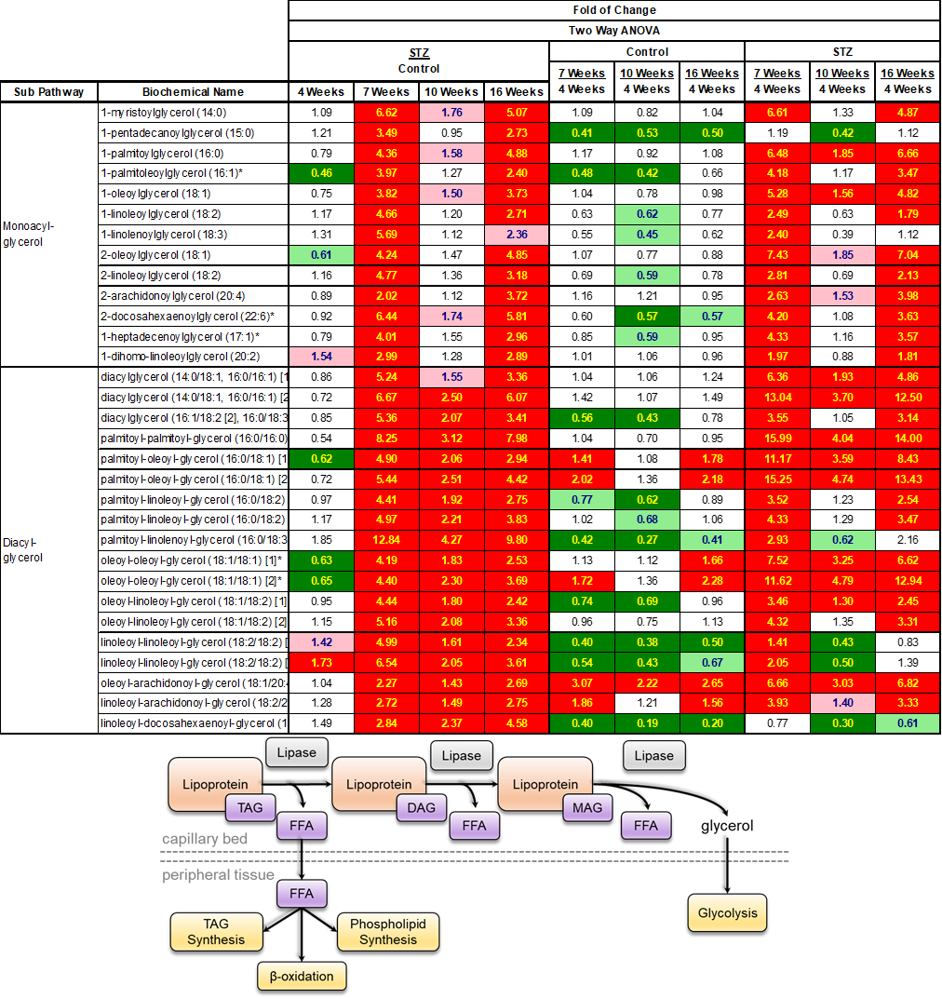
Figure 3. Statistical heat map and pathway diagram of select MAG and DAGs. Trending (0.05 < p < 0.10) and significant (p ≤ 0.05) elevations are indicated by pink and red, respectively, while trending and significant reductions are represented by light green and dark green, respectively.

Further evidence for differences in lipid metabolism is also apparent in levels of free fatty acids (FFA), acylcarnitines, and ketone bodies (Figure 4). While acylcarnitines are generated during beta-oxidation, differences in their levels in serum may reflect a difference in tissue utilization of these compounds (PMID: 29235526). Here we observe elevated levels of free fatty acids at 7 weeks, within the STZ group (vs. Con), this difference is largely absent at 10 weeks, and only observed for stearate at 16 weeks (though stearate appears to be the primary acyl group in the high fat diet). Levels of acylcarnitines though are elevated within the STZ group at 7 weeks and onwards (vs. Con) with this difference largely being driven by changes within the STZ group. Further evidence for a difference in lipid metabolism, is observed in the difference in ketone bodies (often generated during liver beta-oxidation). STZ treatment and a high fat diet results in a large accumulation (as high as a 50-fold increase) of acetoacetate and BHBA within the STZ group (again driven by changes within the STZ group). These differences may suggest a differential utilization of lipids for energy production by the liver, and potentially the periphery, in response to STZ treatment.

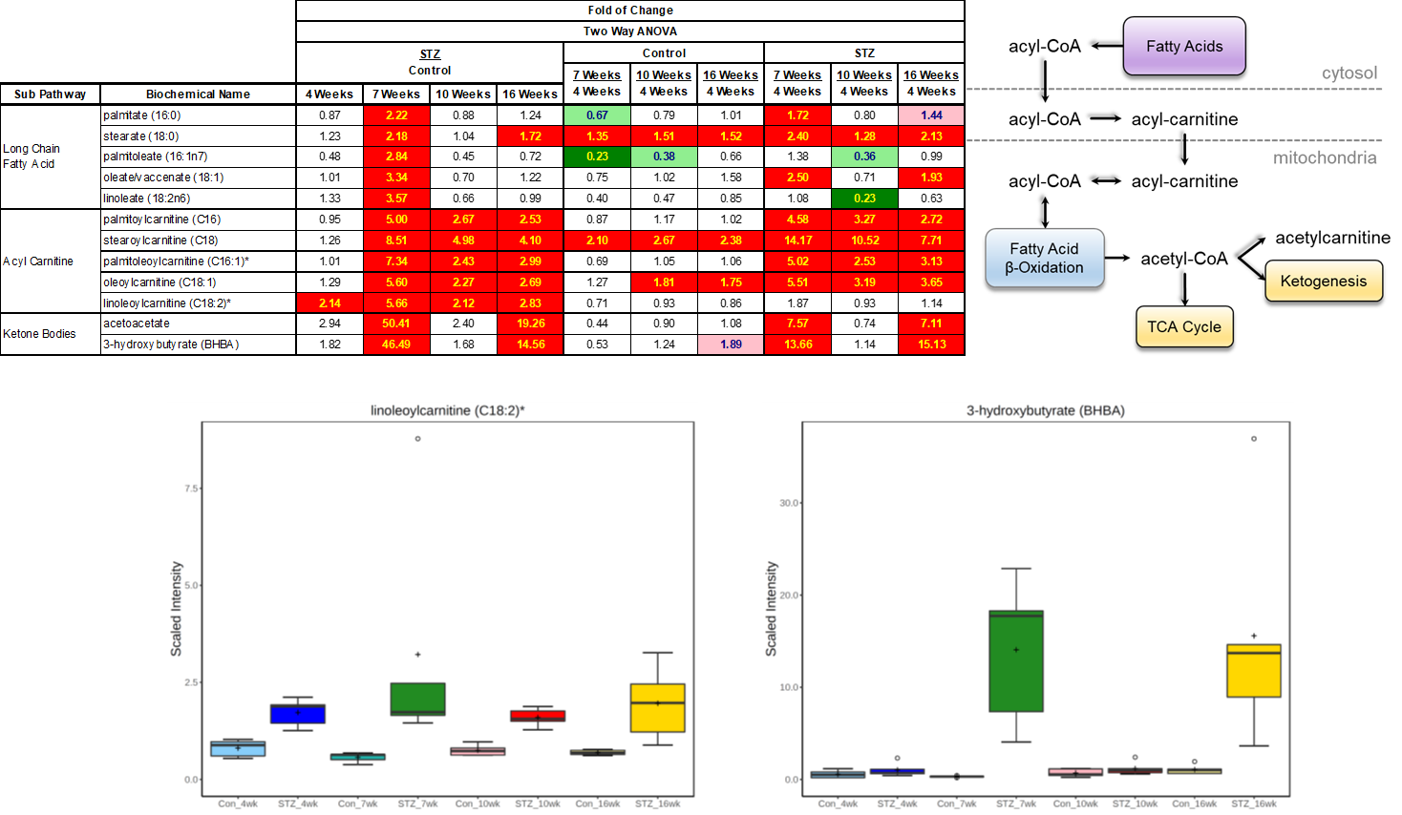

Figure 4. Statistical heat map, box plots, and pathway diagram of metabolites associated with lipid oxidation. Trending (0.05 < p < 0.10) and significant (p ≤ 0.05) elevations are indicated by pink and red, respectively, while trending and significant reductions are represented by light green and dark green, respectively.

Another mechanism by which the liver interacts with peripheral lipid metabolism is by acting on and releasing lipoproteins, which are the primary method of lipid transport within the circulation. These lipoproteins are also rich in cholesterol, and as such changes in cholesterol levels may reflect a difference in total circulating lipoproteins or the ratio of HDL to LDL. Here we observe a robust difference in levels of cholesterol (and cholesterol sulfate) between the STZ and control group, with elevated levels present within the STZ group (Figure 5). Both control and STZ treated mice appear to have increased levels of cholesterol at later time points, as compared to the 4-week time point, but this increase is greater within STZ treated mice. This difference may suggest a difference in how the liver from STZ treated mice are processing and exporting lipids.

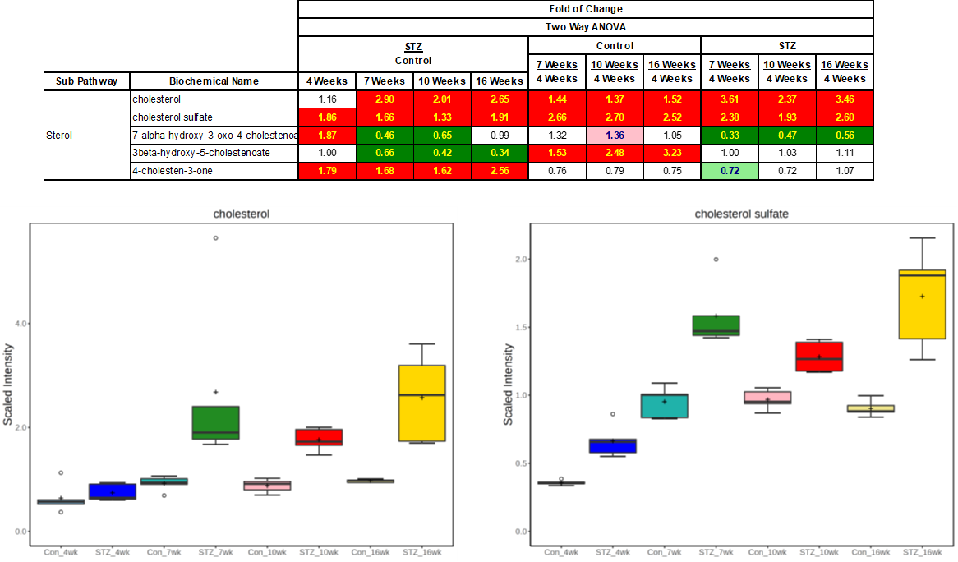
Figure 5. Statistical heat map and box plots of metabolites associated with cholesterol metabolism. Trending (0.05 < p < 0.10) and significant (p ≤ 0.05) elevations are indicated by pink and red, respectively, while trending and significant reductions are represented by light green and dark green, respectively.

Phospholipids Metabolism
Phospholipids make up the largest proportion of cell membrane lipids and proliferating cells either import these essential compounds from the circulation or synthesize new phospholipids from diacylglycerols and polar head groups such as choline or ethanolamine. Phosphatidylcholine (PC) and phosphatidylethanolamine (PE) make up the largest proportion of membrane phospholipids.

Similar to the observations made with MAG and DAGs, levels of the majority of complex lipids within circulation were elevated within the STZ group (as compared to Con) when on the high fat diet (PE and PC shown in Figure 6). As with cholesterol, this increase over time is apparent in both the Control and STZ group, though more robustly increased within the STZ group. These differences may suggest these lipids are diet derived (chylomicron packing) and maybe a consequence of impaired clearance of these chylomicrons.
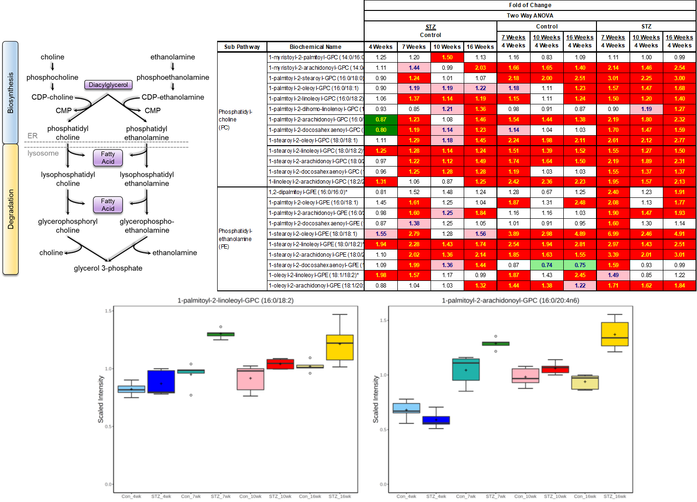
Figure 6. Statistical heat map, pathway diagram, and box plots of select PCs and PEs. Trending (0.05 < p < 0.10) and significant (p ≤ 0.05) elevations are indicated by pink and red, respectively, while trending and significant reductions are represented by light green and dark green, respectively.

Branched Chain Amino Acids
The first step in branched chain amino acids (BCAA) catabolism is the deamination of the BCAA and generation of branched chain keto acids. This process releases ammonia for incorporation into other compounds. An inability to fully catabolize BCAA amino acids often results in the formation of end-products (e.g., 2-hydroxy-3-methylvalerate) that are excreted in the urine. As such these compounds offer insights into mitochondrial function, in addition to oxidative stress and BCAA catabolism (PMID: 11894849).

Here we observe that the levels of branched chain amino acids are influenced by STZ treatment as well as dietary composition (Figure 7). As the levels of parent BCAAs can additionally influence glucose and lipid regulation, this may be a mechanism by which STZ treatment influences liver metabolism (PMID: 32184272). Furthermore, the accumulation of downstream products of BCAA catabolism, particularly in the STZ treated group, suggests an inability to fully metabolize greater amounts of BCAA. As muscle and liver are common sites of BCAA metabolism, it is unclear which of these tissues is contributing to these changes.
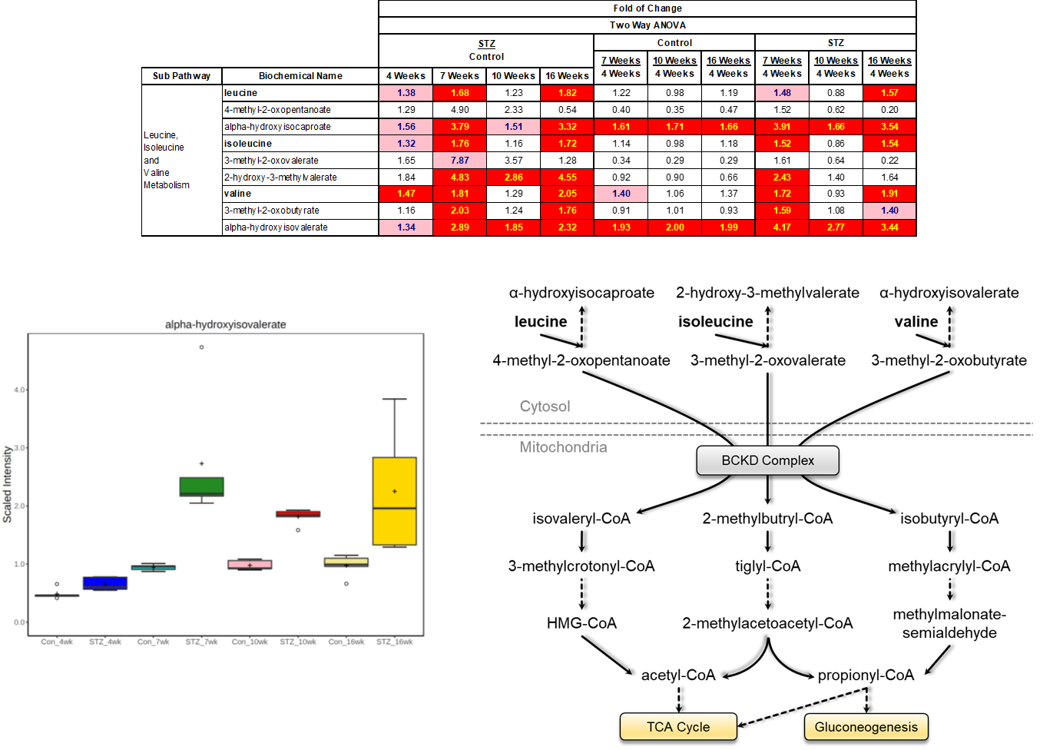
Figure 7. Statistical heat map, pathway diagram, and box plots of bile acids. Trending (0.05 < p < 0.10) and significant (p ≤ 0.05) elevations are indicated by pink and red, respectively, while trending and significant reductions are represented by light green and dark green, respectively.

Conclusions

This global metabolic profiling study was conducted to characterize the impact of STZ treatment and high fat diet on the circulating metabolites. Several metabolites and pathways appeared to be impacted by these factors, notably energetics and lipid metabolism pathways. Consequences of STZ treatment were observed as novel differences not observed within the CON group, as well as an exacerbation of high fat feeding.

Future studies would benefit from additionally examining the liver as was as directly assessing circulating lipoprotein levels. Examining different models of impaired glucose metabolism (e.g., insulin insensitivity) may also reveal other changes not evident here.

Study Parameters

Data Quality: Instrument and Process Variability

QC Sample | Measurement | Median RSD
Internal Standards | Instrument Variability | 4%
Endogenous Biochemicals | Total Process Variability | 6%
Instrument variability was determined by calculating the median relative standard deviation (RSD) for the internal standards that were added to each sample prior to injection into the mass spectrometers. Overall process variability was determined by calculating the median RSD for all endogenous metabolites (i.e., non-instrument standards) present in 100% of the Client Matrix samples, which are technical replicates of pooled client samples. Values for instrument and process variability meet Metabolon’s acceptance criteria as shown in the table above.

Appendix

Metabolon Platform
Sample Accessioning: Following receipt, samples were inventoried and immediately stored at -80ºC. Each sample received was accessioned into the Metabolon LIMS system and was assigned by the LIMS a unique identifier that was associated with the original source identifier only. This identifier was used to track all sample handling, tasks, results, etc. The samples (and all derived aliquots) were tracked by the LIMS system. All portions of any sample were automatically assigned their own unique identifiers by the LIMS when a new task was created; the relationship of these samples was also tracked. All samples were maintained at -80ºC until processed.
Sample Preparation: Samples were prepared using the automated MicroLab STAR® system from Hamilton Company. Several recovery standards were added prior to the first step in the extraction process for QC purposes. To remove protein, dissociate small molecules bound to protein or trapped in the precipitated protein matrix, and to recover chemically diverse metabolites, proteins were precipitated with methanol under vigorous shaking for 2 min (Glen Mills GenoGrinder 2000) followed by centrifugation. The resulting extract was divided into five fractions: two for analysis by two separate reverse phase (RP)/UPLC-MS/MS methods with positive ion mode electrospray ionization (ESI), one for analysis by RP/UPLC-MS/MS with negative ion mode ESI, one for analysis by HILIC/UPLC-MS/MS with negative ion mode ESI, and one sample was reserved for backup. Samples were placed briefly on a TurboVap® (Zymark) to remove the organic solvent. The sample extracts were stored overnight under nitrogen before preparation for analysis.
QA/QC: Several types of controls were analyzed in concert with the experimental samples: a pooled matrix sample generated by taking a small volume of each experimental sample (or alternatively, use of a pool of well-characterized human plasma) served as a technical replicate throughout the data set; extracted water samples served as process blanks; and a cocktail of QC standards that were carefully chosen not to interfere with the measurement of endogenous compounds were spiked into every analyzed sample, allowed instrument performance monitoring and aided chromatographic alignment. Tables 1 and 2 describe these QC samples and standards. Instrument variability was determined by calculating the median relative standard deviation (RSD) for the standards that were added to each sample prior to injection into the mass spectrometers. Overall process variability was determined by calculating the median RSD for all endogenous metabolites (i.e., non-instrument standards) present in 100% of the pooled matrix samples. Experimental samples were randomized across the platform run with QC samples spaced evenly among the injections, as outlined in Figure 1.
Table 1: Description of Metabolon QC Samples
Type | Description | Purpose
MTRX | Large pool of human plasma maintained by Metabolon that has been characterized extensively. | Assure that all aspects of the Metabolon process are operating within specifications.
CMTRX | Pool created by taking a small aliquot from every customer sample. | Assess the effect of a non-plasma matrix on the Metabolon process and distinguish biological variability from process variability.
PRCS | Aliquot of ultra-pure water | Process Blank used to assess the contribution to compound signals from the process.
SOLV | Aliquot of solvents used in extraction. | Solvent Blank used to segregate contamination sources in the extraction.
Table 2: Metabolon QC Standards
Type | Description | Purpose
RS | Recovery Standard | Assess variability and verify performance of extraction and instrumentation.
IS | Internal Standard | Assess variability and performance of instrument.

Figure 1. Preparation of client-specific technical replicates. A small aliquot of each client sample (colored cylinders) is pooled to create a CMTRX technical replicate sample (multi-colored cylinder), which is then injected periodically throughout the platform run. Variability among consistently detected biochemicals can be used to calculate an estimate of overall process and platform variability.
Ultrahigh Performance Liquid Chromatography-Tandem Mass Spectroscopy (UPLC-MS/MS): All methods utilized a Waters ACQUITY ultra-performance liquid chromatography (UPLC) and a Thermo Scientific Q-Exactive high resolution/accurate mass spectrometer interfaced with a heated electrospray ionization (HESI-II) source and Orbitrap mass analyzer operated at 35,000 mass resolution. The sample extract was dried then reconstituted in solvents compatible to each of the four methods. Each reconstitution solvent contained a series of standards at fixed concentrations to ensure injection and chromatographic consistency. One aliquot was analyzed using acidic positive ion conditions, chromatographically optimized for more hydrophilic compounds. In this method, the extract was gradient eluted from a C18 column (Waters UPLC BEH C18-2.1x100 mm, 1.7 µm) using water and methanol, containing 0.05% perfluoropentanoic acid (PFPA) and 0.1% formic acid (FA). Another aliquot was also analyzed using acidic positive ion conditions, however it was chromatographically optimized for more hydrophobic compounds. In this method, the extract was gradient eluted from the same afore mentioned C18 column using methanol, acetonitrile, water, 0.05% PFPA and 0.01% FA and was operated at an overall higher organic content. Another aliquot was analyzed using basic negative ion optimized conditions using a separate dedicated C18 column. The basic extracts were gradient eluted from the column using methanol and water, however with 6.5mM Ammonium Bicarbonate at pH 8. The fourth aliquot was analyzed via negative ionization following elution from a HILIC column (Waters UPLC BEH Amide 2.1x150 mm, 1.7 µm) using a gradient consisting of water and acetonitrile with 10mM Ammonium Formate, pH 10.8. The MS analysis alternated between MS and data-dependent MS^{n} scans using dynamic exclusion. The scan range varied slighted between methods but covered 70-1000 m/z. Raw data files are archived and extracted as described below.
Bioinformatics: The informatics system consisted of four major components, the Laboratory Information Management System (LIMS), the data extraction and peak-identification software, data processing tools for QC and compound identification, and a collection of information interpretation and visualization tools for use by data analysts. The hardware and software foundations for these informatics components were the LAN backbone, and a database server running Oracle 10.2.0.1 Enterprise Edition.
LIMS: The purpose of the Metabolon LIMS system was to enable fully auditable laboratory automation through a secure, easy to use, and highly specialized system. The scope of the Metabolon LIMS system encompasses sample accessioning, sample preparation and instrumental analysis and reporting and advanced data analysis. All of the subsequent software systems are grounded in the LIMS data structures. It has been modified to leverage and interface with the in-house information extraction and data visualization systems, as well as third party instrumentation and data analysis software.
Data Extraction and Compound Identification: Raw data was extracted, peak-identified and QC processed using Metabolon’s hardware and software. These systems are built on a web-service platform utilizing Microsoft’s .NET technologies, which run on high-performance application servers and fiber-channel storage arrays in clusters to provide active failover and load-balancing. Compounds were identified by comparison to library entries of purified standards or recurrent unknown entities. Metabolon maintains a library based on authenticated standards that contains the retention time/index (RI), mass to charge ratio (m/z), and chromatographic data (including MS/MS spectral data) on all molecules present in the library. Furthermore, biochemical identifications are based on three criteria: retention index within a narrow RI window of the proposed identification, accurate mass match to the library +/- 10 ppm, and the MS/MS forward and reverse scores between the experimental data and authentic standards. The MS/MS scores are based on a comparison of the ions present in the experimental spectrum to the ions present in the library spectrum. While there may be similarities between these molecules based on one of these factors, the use of all three data points can be utilized to distinguish and differentiate biochemicals. More than 3300 commercially available purified standard compounds have been acquired and registered into LIMS for analysis on all platforms for determination of their analytical characteristics. Additional mass spectral entries have been created for structurally unnamed biochemicals, which have been identified by virtue of their recurrent nature (both chromatographic and mass spectral). These compounds have the potential to be identified by future acquisition of a matching purified standard or by classical structural analysis.
Curation: A variety of curation procedures were carried out to ensure that a high quality data set was made available for statistical analysis and data interpretation. The QC and curation processes were designed to ensure accurate and consistent identification of true chemical entities, and to remove those representing system artifacts, mis-assignments, and background noise. Metabolon data analysts use proprietary visualization and interpretation software to confirm the consistency of peak identification among the various samples. Library matches for each compound were checked for each sample and corrected if necessary.

Metabolite Quantification and Data Normalization: Peaks were quantified using area-under-the-curve. For studies spanning multiple days, a data normalization step was performed to correct variation resulting from instrument inter-day tuning differences. Essentially, each compound was corrected in run-day blocks by registering the medians to equal one (1.00) and normalizing each data point proportionately (termed the “block correction”; Figure 2). For studies that did not require more than one day of analysis, no normalization is necessary, other than for purposes of data visualization. In certain instances, biochemical data may have been normalized to an additional factor (e.g., cell counts, total protein as determined by Bradford assay, osmolality, etc.) to account for differences in metabolite levels due to differences in the amount of material present in each sample.
Figure 2: Visualization of data normalization steps for a multiday platform run.

Statistical Methods and Terminology
Statistical Calculations: For many studies, two types of statistical analysis are usually performed: (1) significance tests and (2) classification analysis. Standard statistical analyses are performed in ArrayStudio on log transformed data. For those analyses not standard in ArrayStudio, the programs R (http://cran.r-project.org/) or JMP are used. Below are examples of frequently employed significance tests and classification methods followed by a discussion of p- and q-value significance thresholds.

- One-way ANOVA
ANOVA stands for analysis of variance. For ANOVA, it is assumed that all populations have the same variances. One-way ANOVA is used to test whether at least two unknown means are all equal or whether at least one pair of means is different. For the case of two means, ANOVA gives the same result as a two-sided t-test with a pooled estimate of the variance.

An ANOVA uses an F-test which has two parameters – the numerator degrees of freedom and the denominator degrees of freedom. The degrees of freedom in the numerator are equal to g – 1, where g is the number of groups. If n is the total number of observations (n₁ + n₂), then, the denominator degrees of freedom is equal to n – g. The F-statistic is the ratio of the between-groups variance to the within-groups variance, hence the higher the F-statistic the more evidence we have that the means are different.

Often within ANOVA, one performs linear contrasts for specific comparisons of interest. For example, suppose we have three groups A, B, C, then examples of some contrasts are A vs. B, the average of A and B vs. C, etc. For single-degree of freedom contrasts, these give the same result as a two-sided t-test with the pooled estimate of the variance from the ANOVA and degrees of freedom n – g. Below, we show the three formulas for A vs. B from a three group design as shown above. The numerator is same in each case, but the denominator differs by the estimates of the variances, and the degrees of freedom are different for each (if the theoretical assumptions hold, then the contrast has the most power, as it has the largest degrees of freedom).

Welch’s two-sample t-test
By t $= ({\overline{x}}_{A}-{\overline{x}}_{B})/\sqrt{s_{A}^{2}/n_{A}+s_{B}^{2}/n_{B}}$ , and the degrees of freedom is given by ${\left(\frac{s_{A}^{2}}{n_{A}}+\frac{s_{B}^{2}}{n_{B}}\right)}^{2}/\left(\frac{{\left(\frac{s_{A}^{2}}{n_{A}}\right)}^{2}}{n_{A}-1}+\frac{{\left(\frac{s_{B}^{2}}{n_{B}}\right)}^{2}}{n_{B}-1}\right)$

Two-sample t-test with pooled estimate of variance from A and B
$$t= ({\overline{x}}_{A}-{\overline{x}}_{B})/\sqrt{s_{AB}^{2}(1/n_{A}+/n_{B}})$$
where $s_{AB}^{2}=\left(\left(n_{A}-1\right)s_{A}^{2}+\left(n_{B}-1\right)s_{B}^{2}\right)/(n_{A}+n_{B}-2)$, where the degrees of freedom is n_{A} + n_{B} – 2.
The contrast from the ANOVA,
$$t= ({\overline{x}}_{A}-{\overline{x}}_{B})/\sqrt{s^{2}\left(1/n_{A}+/n_{B}\right)}$$
where $s^{2}=\left(\left(n_{A}-1\right)s_{A}^{2}+\left(n_{B}-1\right)s_{B}^{2} + \left(n_{C}-1\right)s_{C}^{2}\right)/(n_{A}+n_{B}+ n_{C}-3)$, where the degrees of freedom is given by where the degrees of freedom is n_{A} + n_{B} + n_{C} – 3.

- Two-way ANOVA
ANOVA stands for analysis of variance. For ANOVA, it is assumed that all populations have the same variances. For a two-way ANOVA, three statistical tests are typically performed: the main effect of each factor and the interaction. Suppose we have two factors A and B, where A represent the genotype and B represent the diet in a mouse study. Suppose each of these factors has two levels (A: wild type, knock out; B: standard diet, high fat diet). For this example, there are 4 combinations (“treatments”): A1B1, A1B2, A2B1, A2B2. The overall ANOVA F-test gives the p-value for testing whether all four of these means are equal or whether at least one pair is different. However, we are also interested in the effect of the genotype and diet. A main effect is a contrast that tests one factor across the levels of the other factor. Hence the A main effect compares (A1B1 + A1B2)/2 vs. (A2B1 + A2B2)/2, and the B-main effect compares (A1B1 + A2B1)/2 vs. (A1B2 + A2B2)/2. The interaction is a contrast that tests whether the mean difference for one factor depends on the level of the other factor, which is (A1B2 + A2B1)/2 vs. (A1B1 + A2B2)/2.

Some sample plots follow. For the first plot, there is a B main effect, but no A main effect and no interaction, as the effect of B does not depend on the level of A. For the second plot, notice how the mean difference for B is the same at each level of A and the difference in A is the same for each level of B, hence there is no statistical interaction. The final plot also has main effects for A and B, but here also has an interaction: we see the effect of B depends on the level of A (0 for A1 but 2 for A2), i.e., the effect of the diet depends on the genotype. We also see here the interpretation of the main effects depends on whether there is an interaction or not.

- p- values
For statistical significance testing, p-values are given. The lower the p-value, the more evidence we have that the null hypothesis (typically that two population means are equal) is not true. If “statistical significance” is declared for p-values less than 0.05, then 5% of the time we incorrectly conclude the means are different, when actually they are the same.

The p-value is the probability that the test statistic is at least as extreme as observed in this experiment given that the null hypothesis is true. Hence, the more extreme the statistic, the lower the p-value and the more evidence the data gives against the null hypothesis.

- q-values
The level of 0.05 is the false positive rate when there is one test. However, for a large number of tests we need to account for false positives. There are different methods to correct for multiple testing. The oldest methods are family-wise error rate adjustments (Bonferroni, Tukey, etc.), but these tend to be extremely conservative for a very large number of tests. With gene arrays, using the False Discovery Rate (FDR) is more common. The family-wise error rate adjustments give one a high degree of confidence that there are zero false discoveries. However, with FDR methods, one can allow for a small number of false discoveries. The FDR for a given set of compounds can be estimated using the q-value (see Storey J and Tibshirani R. (2003) Statistical significance for genomewide studies. Proc. Natl. Acad. Sci. USA 100: 9440-9445; PMID: 12883005).

In order to interpret the q-value, the data must first be sorted by the p-value then choose the cutoff for significance (typically p<0.05). The q-value gives the false discovery rate for the selected list (i.e., an estimate of the proportion of false discoveries for the list of compounds whose p-value is below the cutoff for significance). For Table 1 below, if the whole list is declared significant, then the false discovery rate is approximately 10%. If everything from Compound 079 and above is declared significant, then the false discovery rate is approximately 2.5%.
Table 1: Example of q-value interpretation

- Principal Components Analysis (PCA)
Principal components analysis is an unsupervised analysis that reduces the dimension of the data. Each principal component is a linear combination of every metabolite and the principal components are uncorrelated. The number of principal components is equal to the number of observations.

The first principal component is computed by determining the coefficients of the metabolites that maximizes the variance of the linear combination. The second component finds the coefficients that maximize the variance with the condition that the second component is orthogonal to the first. The third component is orthogonal to the first two components and so on. The total variance is defined as the sum of the variances of the predicted values of each component (the variance is the square of the standard deviation), and for each component, the proportion of the total variance is computed. For example, if the standard deviation of the predicted values of the first principal component is 0.4 and the total variance = 1, then 100*0.4*0.4/1 = 16% of the total variance is explained by the first component. Since this is an unsupervised method, the main components may be unrelated to the treatment groups, and the “separation” does not give an estimate of the true predictive ability.

